CABIN FAN HARNESS:
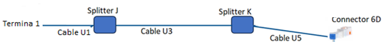

The wiring and connectors information is specified in the following tables:

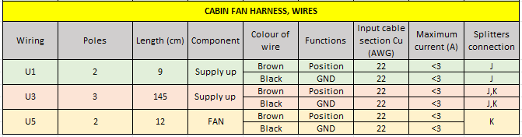
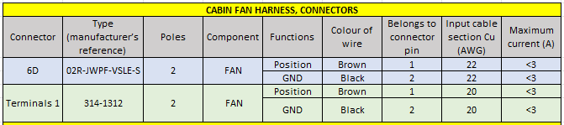
.

Terminals 1 refers to assembly only the specified terminals without any connector

CAMERA HARNESS:

In this harness it is necessary to use a special cable, to avoid interferences in the camera signal, for this reason we want to use the RG59 + DC COMBINED CABLE. The consumption of the camera and the display is 0.2 Amperes, so we use 24AWG cables (with this section is enough).
The wiring and connectors information is specified in the following tables:

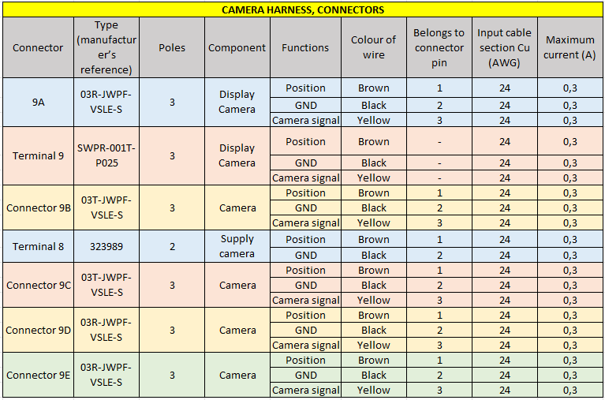
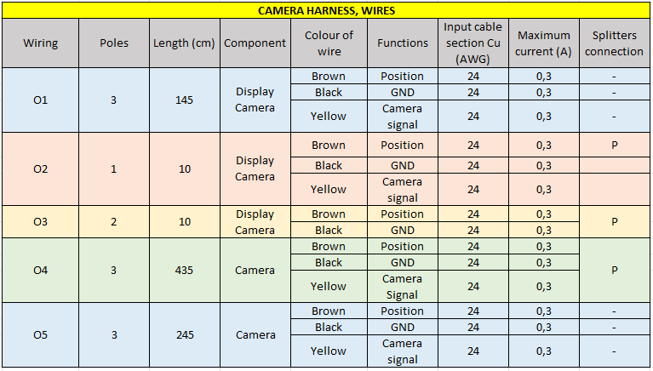

CAN HARNESS:

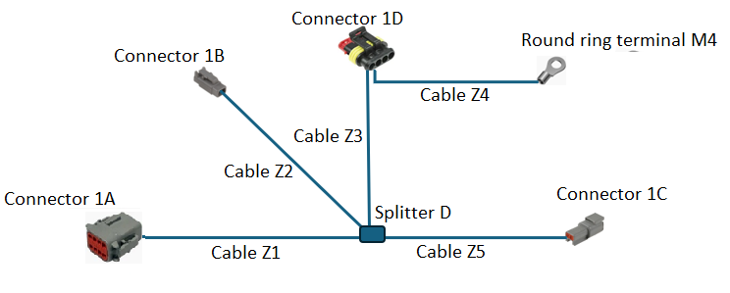

The wiring and connectors information is specified in the following tables:
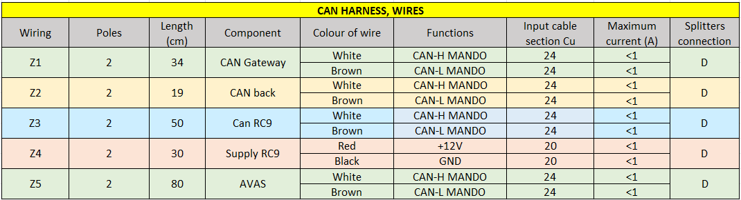
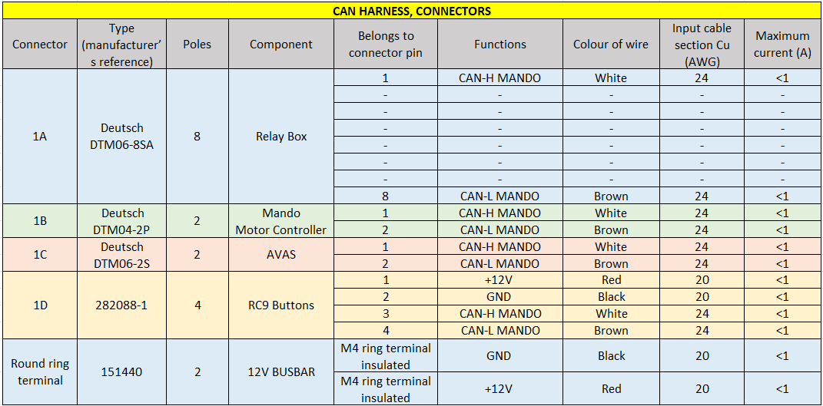

Z1, Z2, Z3 and Z5 CAN cables are twisted pair, conductors: 7-wire strands of bare copper, insulation Polyethylene or PVC. For CAN-based communication systems such as CANopen. Flame retardant according to IEC 60332-1-2, temperature range from -40°C to +80°C.
Z4 power and control cable, PVC single core for field wiring. con certificación UL (MTW), Canadá CSA (TEW), Europa: H07V-K (as a function of the cross section)
FRONT LIGHT HARNESS:

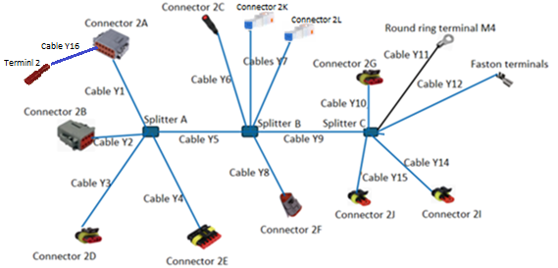
The wiring and connectors information is specified in the following tables:
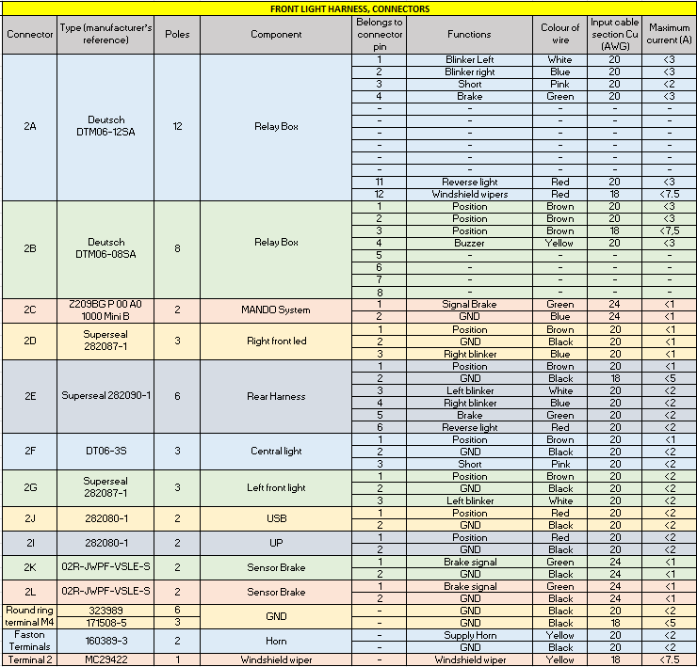
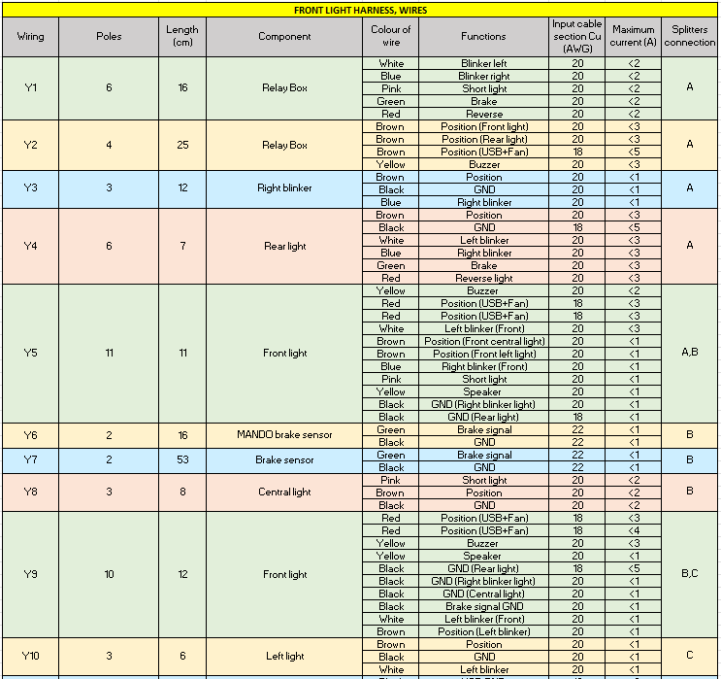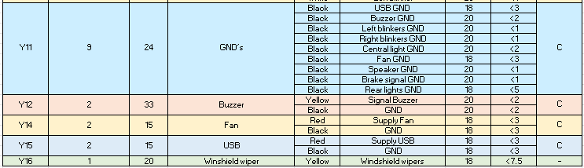
Power and control cable, PVC single core for field wiring. con certification UL (MTW), Canada CSA (TEW), Europe: H07V-K (as a function of the cross section)

SUPPLY 12V RELAYS HARNESS:

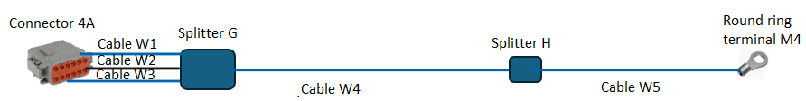

The wiring and connectors information is specified in the following tables:
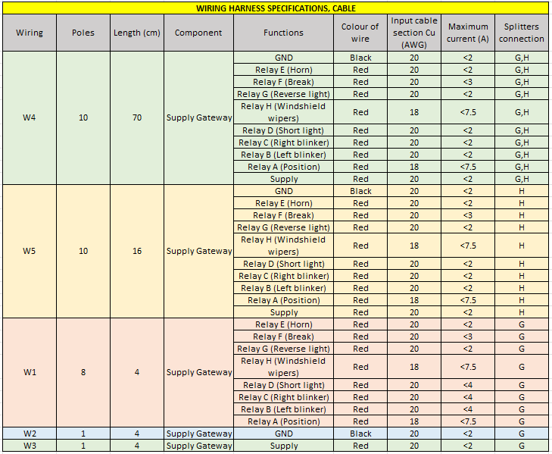
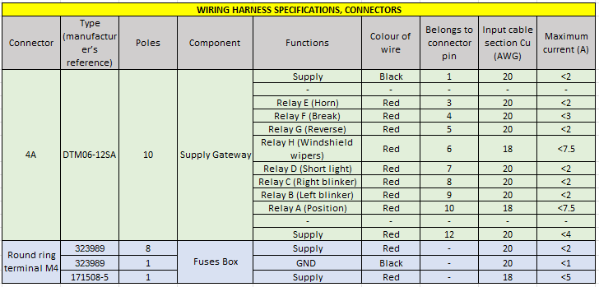

- LEFT TAIL LIGHT HARNESS:

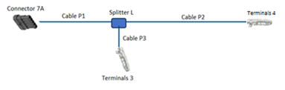

The wiring and connectors information is specified in the following tables:

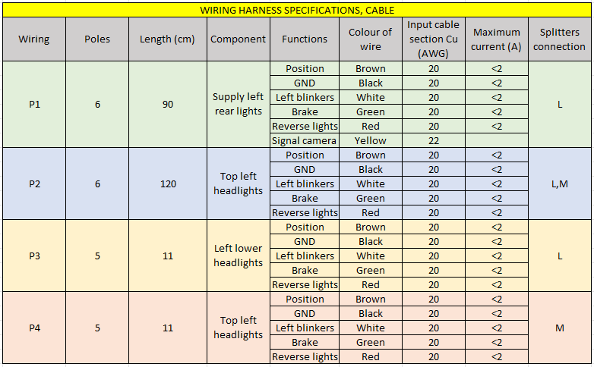
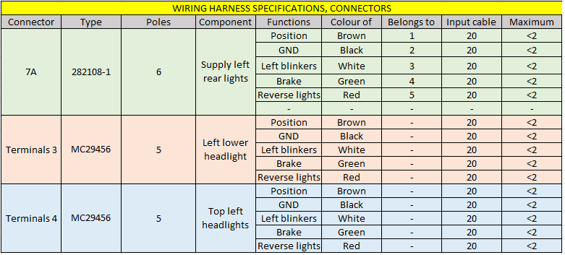

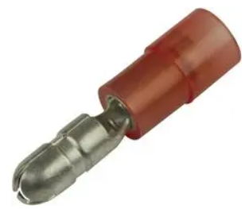
Terminal 3, 4, 5, manufacturer's reference: MC29456

- RIGHT TAIL LIGHT HARNESS:

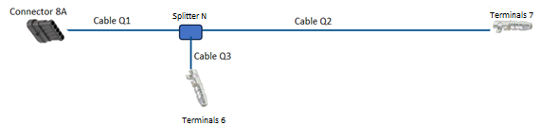

The wiring and connectors information is specified in the following tables:

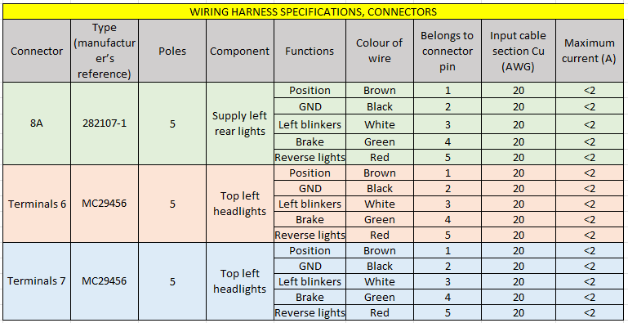

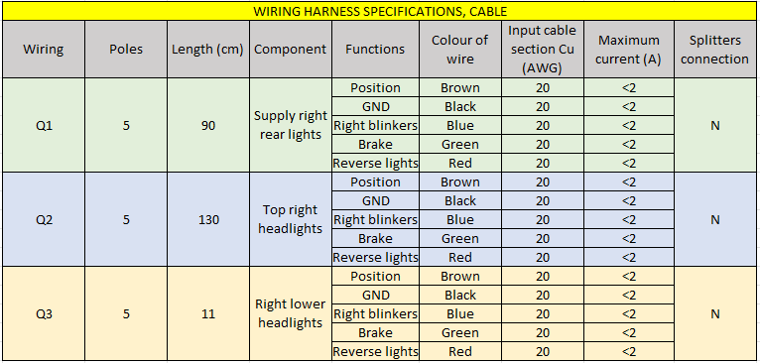

Terminal 6, 7, manufacturer's reference: MC29456

BEAM HARNESS:

This harness consists of several harnesses:
- Rear light harness.
- Can +48V.
- Front harness

The Beam Cable must be protected by corrugated tube and taped with cloth tape to protect it.
Next, I specify the cables that form the beam harness.

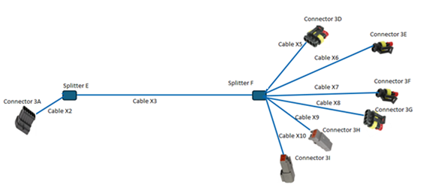
- REAR LIGHT HARNESS:

The wiring and connectors information is specified in the following tables:
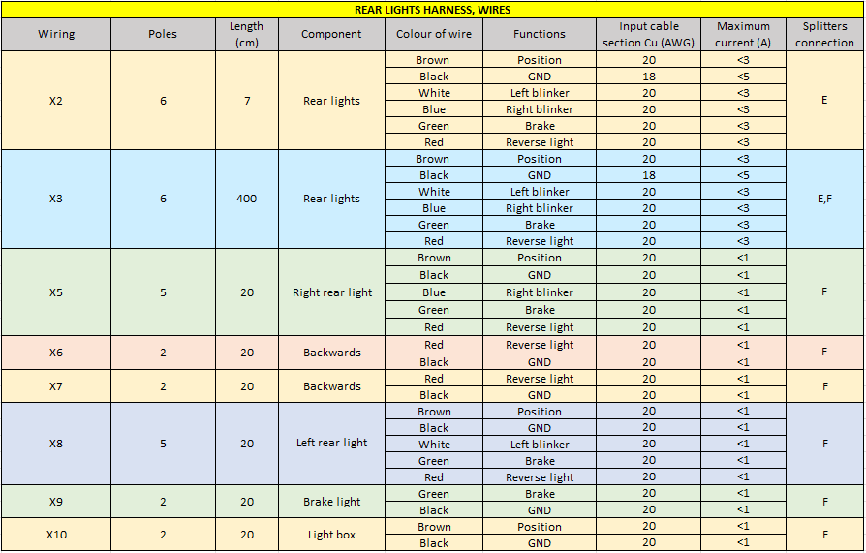
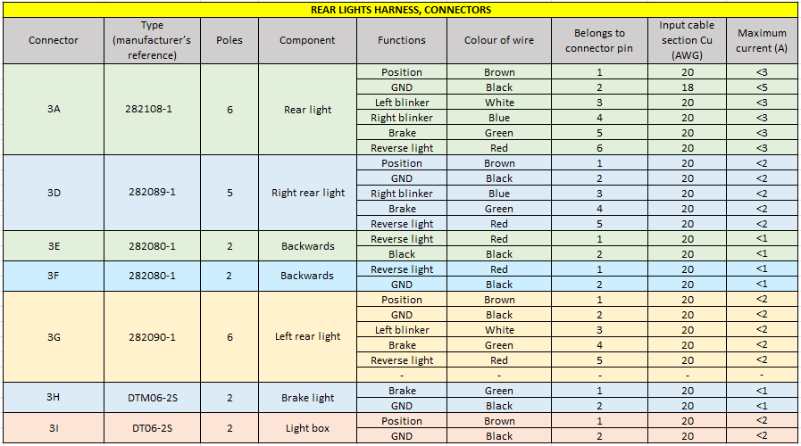

Power and control cable, PVC single core for field wiring. with certification UL (MTW), Canada CSA (TEW), Europe: H07V-K (as a function of the cross section)

- CAN +48V
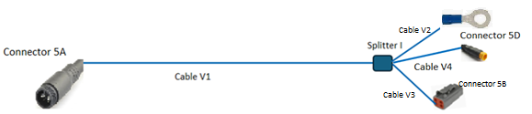
The wiring and connectors information is specified in the following tables:
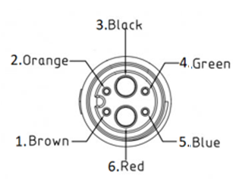
L615AG P. Connector 5A.

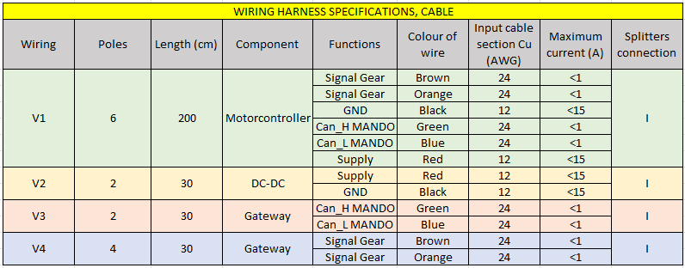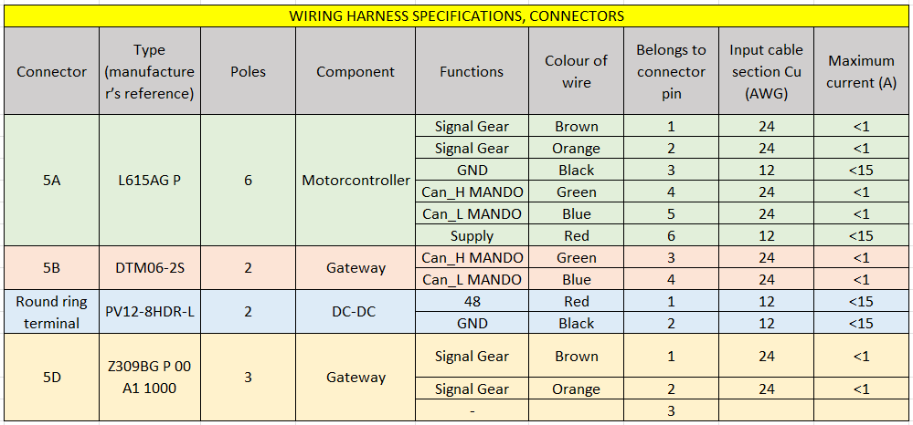
Power and control cable, PVC single core for field wiring. with certification UL (MTW), Canada CSA (TEW), Europa: H07V-K (as a function of the cross section)
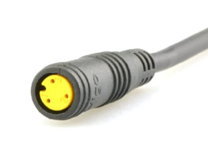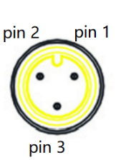
Connector 5D

- FRONT HARNESS
HIGO CONNECTOR cable supplied by us.

